INTERNATIONAL TRAINING COURSE
2-10 July, Codlea, Romania

The training course is open for young people (between 18-30 years old), citizens of one of the participating countries:

Romania
Slovenia
Bulgaria
Greece
France
Nepal
Philippines
Thailand
Vietnam

Participants should have an interested in promoting one of the 17 Sustainable Development Goals promoted by United Nations.

It will be held in Codlea, Romania between 2-10 of July 2016 and will be special designed to help the participants to gain more competencies in the project management and to offer the space to compare their ideas and experiences in the field of their common passions and interest in being active for SDGs.

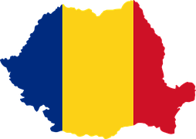

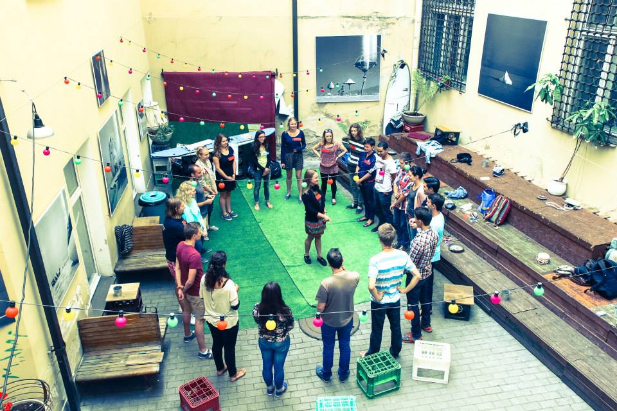

The training is part of the international project Youth in Action for the Sustainable Development Goals with collaboration of 9 country partner organizations. Its goal is to promote and support youth participation in the contribution for the achievement of the Sustainable Development Goals. With the financial support from European Commission, 9 partner organizations from Romania, Slovenia, Bulgaria, Greece, France, Nepal, Philippines, Nepal and Vietnam will be elaborating on a collaboration hub to encourage youth initiatives to solve social issues in accordance with 17 SDGs.

