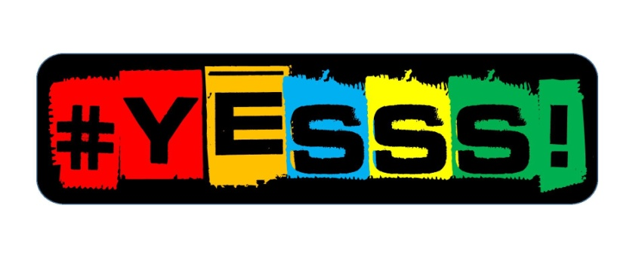

Thank you for partecipating in Yesss Contest!
To be valid this and must be completed in full and send back to yessscontest@gmail.com. The contest closes on 15th September 2016.

General information
Name of the enterpreneur (s):
Age:
occupation:
Venture’s name:
Email:
Address:
Mobile:
Skype:

Sector:
- Arts, heritage, sport
- Employment, training and education
- Environmental
- Family, friends and relationships
- Housing and local facilities
- Income and financial inclusion
- Mental health and wellbeing
- Physical health
- Others: …………………………..

YOUR IDEA
Tell us about your idea in one brief paragraph.

(400 characters)

IDEA OR PROJECT DESCRIPTION
Tell us about your soclution for a sustainable society. Explain us more about your product, the market in which you work and the target customers who buy your product or service.
Describe you product or service that you will offer, your market approch, your key costumers and how it can improve your community.

(2000 characters)

SOCIAL PROBLEM
Describe the social problem addressed and the how sustable is your idea.
-What is the social problem you have identified and how your solution will help in effectivelly adress this social problem?
-What change do you want to see in your local community?
-What is the key problem you want to tackle?
Outline your goal for a social impact.

(1000 characters)

MOTIVATION AND FUTURE PLAN
Tell us about your motivations and ideas how to implement the idea in the future. Tell us about your plans after winning this contest and ambitions to scale your idea.

(450 characters)

RESOURCES
What are your investment requirements to achive your goal?
What resources do you need to implement your idea? Or what do you need to start your venture?

(600 characters)

Please upload along with this document a creative presentation of your idea. Could be a short video, a online presentation, pictures or graphic project about your idea to we have more understanding of your idea.

