Short term project in Xylokastro
In this project 10 volunteers from European countries provide additional support to the instructors and other staff working for the environment of Xylokastro - Evrostini municipality.

Description of the tasks of the volunteers:
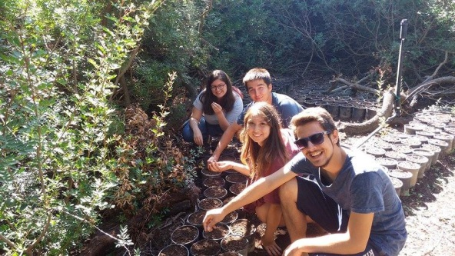
1. Protection of the forest (the volunteers will take care of the natural forest of Xylokastro and Derveni. They will take care of the regular watering of the trees, in particular the new trees, which need more and systematic watering. The volunteers will take care of the cleanness of the walking road of the forest; rake the leaves, twigs, cones from that.
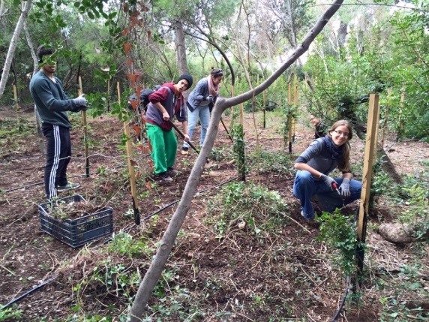
Moreover the volunteers will take care of the health of the trees; they will cut the branches, twigs, always with the superviser and other members and workers of the municipality.)
2. Protection of the coast of Xylokastro and Derveni (the volunteers will take care of the coast beside the forest from the damaging and the human threats like pour out oil to the sea, or on the coast, throw out the rubish…etc.)
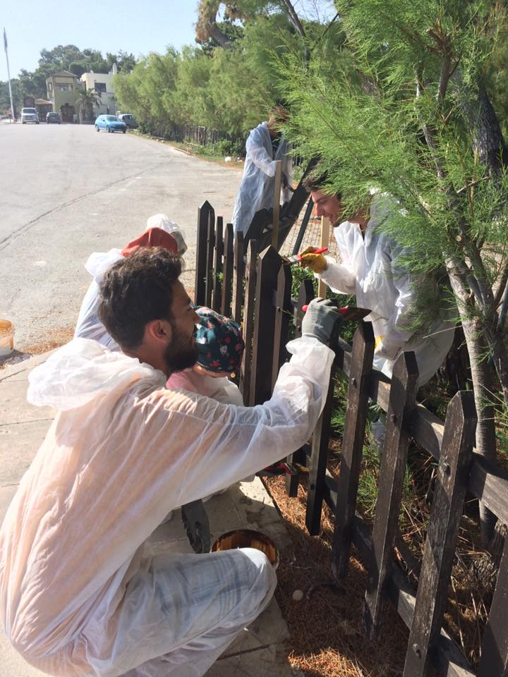
3. The volunteers will participate in planting trees in the forest and in the mountainside of the Municipality (Ziria) All the equipments, tools, new plants, travel and special guidance are provided by the municipality.)
4. The volunteers will help making new and repairing the old footpath in the mountainside of the Municipality (Ziria) the volunteers will be trained how to build and repair the footpath. The tools, materials and transfer for this task will be provided.
5. they will participate to repair the benches, tables, metal and wooden fences in the forest and on the coast.
6. The volunteers will support other environamental activities of the municipality outside of the forest like taking care of parks, the marine, the municipal playground in the forest..etc.
